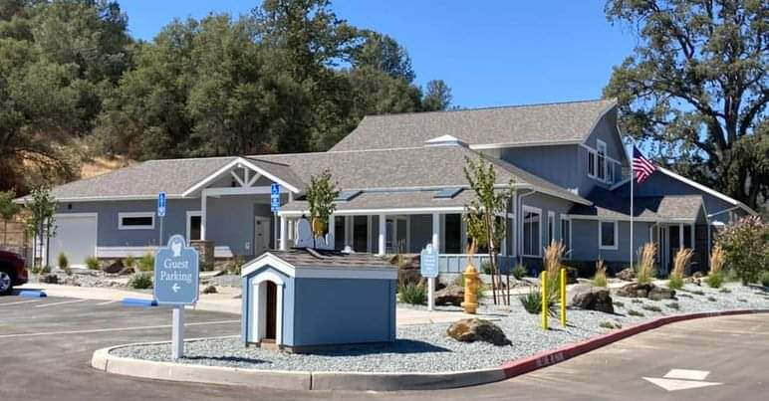

Eastern Madera County SPCA
Strategic Plan
January 1, 2024-December 31, 2024

Introduction:
The Eastern Madera County SPCA (EMCSPCA) was established in 1990 and is dedicated to ensuring the humane treatment of animals in eastern Madera County. The EMCSPCA is a local, independent, non-profit 501c3 organization
(Tax ID#77-0259186) and is supported by private donations.

The EMCSPCA Animal Care and Adoption Center in Ahwahnee was built without any federal, state, or county funding. The state-of-the-art facility provides a unique, healthy environment for dogs and cats awaiting their forever homes. At the heart of everything we do is the welfare of the animals in our care, providing them with the compassion and protection they require when they come to us, from the time they enter our care until they go to their forever homes.

We would like to take this opportunity to thank those who have been part of our mission over the years. It is with the support of our many donors and volunteers that we can do what we do, and your support is invaluable. Our very successful first year of operation is a testament to the support of our community. The outlook for the EMCSPCA heading into the future is bright, thanks to your support.

Our sincerest gratitude,
Sharon Fitzgerald, President
Linda Chappell, Vice President
Nancy Swanson, Secretary
Lyle Swanson, Treasurer
Jeanette Hanneman, Board Member
Don Cohn, Board Member

EMCSPCA Animal Care and Adoption Center
43180 Highway 49, Ahwahnee, CA 93601
559-404-0925

Our Mission:
To provide dogs and cats in our care, with the services they need to increase their adoptability and to provide a safe and loving environment until they find their forever home.

In doing so, we strive to educate the general public to have a responsible and positive attitude toward animals and their welfare.

The EMCSPCA searches for permanent, quality homes for our dogs and cats, and seeks to match the right pet with the right family.

We actively support, encourage, and promote spaying and neutering of all cats and dogs. We pride ourselves on our no-kill policy, which means that the animals in our care stay with us for as long as it takes to find their forever home.

Underpinning our work is the concept of the Five Animal Freedoms. These internationally adopted standards of the care of companion animals are at the heart of all of our activities, and help us to promote the physical and mental health of our dogs and cats.

Freedom from hunger or thirst.
Freedom from discomfort.
Freedom from pain, injury, or disease.
Freedom from fear and distress.
Freedom to express normal behavior.

Our Goals:
We will provide a sanctuary for surrendered animals until they go to their new home. While they are at the Center, they will receive medical care including vaccinations, spay and neuter surgeries and any additional protection against common diseases. We also provide training and socialization to improve their adoptability.

We are committed to improving the general public’s attitude toward animal welfare in eastern Madera County through education programs at local schools, sessions at the Center, and by speaking at local meetings and events.

We will continue to provide monthly low-cost microchip clinics in order to help promote responsible tracking of animals and to enable more stray pets to be reunited with their owners.

One of our major goals for 2024 is to hire part-time clinic staff including a veterinarian, veterinary technician, and assistant. This will allow us to provide in-house care for the Center animals and ultimately provide low-cost vaccination and spay/neuter clinics for locally owned dogs and cats.

We will continue to provide an up-to-date social media presence using our Facebook page, our Instagram account, and our website www.emcspca.org, to provide information regarding animals that are available for adoption, fundraising, volunteering, and special events.

Fundraising will include quarterly events such as a “Kitten Shower” in the first quarter that features a guest speaker from Best Friends Animal Society. Our Amazon Wishlist will be current with items that can be purchased by donors to help stock the Center. Other fundraising events will be planned and announced during the year.

While we hired paid kennel technician employees in 2023, we chose to hire a building maintenance company to perform cleaning duties every two weeks. As the need and finances warrant, we will continue to add to our paid operating staff.

Financial Responsibility:
We will continue to operate the Eastern Madera County SPCA Thrift Shop which is generously supported by community donations. The thrift shop provides a major source of income for our programs. The EMCSPCA relies on the generosity of the community for donations that help us continue our work. Key to the success of the thrift shop is the staff of hard-working volunteers who donate countless hours. We will continue to ensure that our planning and financial control, management, and budgeting are of the utmost standard to ensure our funds are put to the most effective use, and long term sustainability of the organization.

We will continue to provide several different avenues through which donors can support the EMCSPCA.
*Donations made through our website www.emcspca.org
*Dog banks placed in local businesses
*Donations by mail: EMCSPCA, P.O.Box 1314, Oakhurst, CA 93644
*Operation of the EMCSPCA Thrift Shop, 40315 Junction Dr. Ste F, Oakhurst
Open 10am-4pm, Monday through Saturday, phone 559-641-2500
*Quarterly and ongoing fundraising events
*Volunteer post-adoption donations

